Paul Elder, Shibo Xing

pye1, shx26

Firstly, Conflict Equivalence of two histories H and H’ indicates that both histories are defined over the same set of transactions {T1 … Tn}. Thus, the serialization graphs of both histories must contain the exact same set of nodes, which represent the transactions.

Secondly, Conflict Equivalence of two histories indicates that for any pair of conflicting operations pi and qj belonging to non-aborted transactions Ti and Tj, if pi <H qj, then pj <H’ qj.

Similarly, in a serialization graph, any pair of conflicting operations pi and qj belonging to Ti and Tj in the set of transactions {T1 … Tn} would cause a directed edge to be drawn from node Ti to node Tj.

Thus, the serialization graphs of H and H’ would have the same set of directed edges.

Since the serialization graphs of H and H’ have the same sets of edges and nodes, they are identical.

Serialization graphs for each history:

H1: 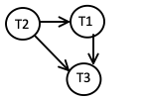

H2: 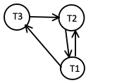

H3: 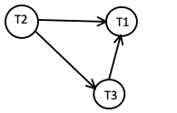

H4: 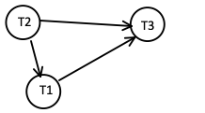

1. H1 and H2 are conflict equivalent since they have the identical serialization graph
2. H1, H3 and H4 are conflict serializable

Equivalent serial history according to their serialization graphs:

H1: T2 -> T1 -> T3

H3: T2 -> T3 -> T1

H4: T2 -> T1 -> T3



H1: not possible

H2: not possible

H3: R3(z)W2(x)R2(z)W2(y)c2;R1(x)R3(x)R3(y)W1(x)c1;c3;

H4: not possible



H1: not possible

H2: not possible

H3: R3(z)W2(x)R2(z)W2(y)c2;R1(x)R3(x)R3(y)c;W1(x)c1;

H4: not possible